**Chapter – 5**

**Activity Time Chart**

**BEFORE MID-SEM :**

03/08/2013 – Got familiar with the fpga kit.

10/08/2013 - Implemented LOGIC gates.

24/08/2013 - Implemented ADDER.

07/09/2013 - Implemented 4 BIT COUNTER.

14/09/2013 - Familarised with the VGA monitor such as timing, horizontal , vertical

Synchronization signal and RGB colours.

05/10/2013 - Implemented the synchronization between the Monitor and the kit and

displayed different colours.

**AFTER MID-SEM :**

26/10/2013 - Implementation of frame on the monitor.

2/11/2013 - Implementation of paddle and ball.

09/11/2013 - Implementation of Game Logic.

16/11/2013 - Rechecking the total code and tries to improve better.

**Chapter – 3**

**Proposed Approach**

This chapter specifies the basic idea about how the project is implemented and how we proceed further.

**3.1 Introduction**

VGA (video graphics array) is a video display standard introduced in the late 1980s in IBM PCs and is widely supported by PC graphics hardware and monitors. We discuss the design of a basic eight-color 640-by-480 resolution interface for CRT (cathode ray tube) monitors in this book. CRT synchronization and basic graphic processing are examined.

**3.2 Basic operation of a CRT**

The conceptual sketch of a monochrome CRT monitor is shown in Figure 13.1. The electron gun (cathode) generates a focused electron beam, which traverses a vacuum tube and eventually hits the phosphorescent screen. Light is emitted at the instant that electrons hit a phosphor dot on the screen. The intensity of the electron beam and the brightness of the dot are determined by the voltage level of the external video input signal, labeled mono in Figure 13.1. The mono signal is an analog signal whose voltage level is between 0 and 0.7 V.

A vertical deflection coil and a horizontal deflection coil outside the tube produce mag- netic fields to control how the electron beam travels and to determine where on the screen the electrons hit.

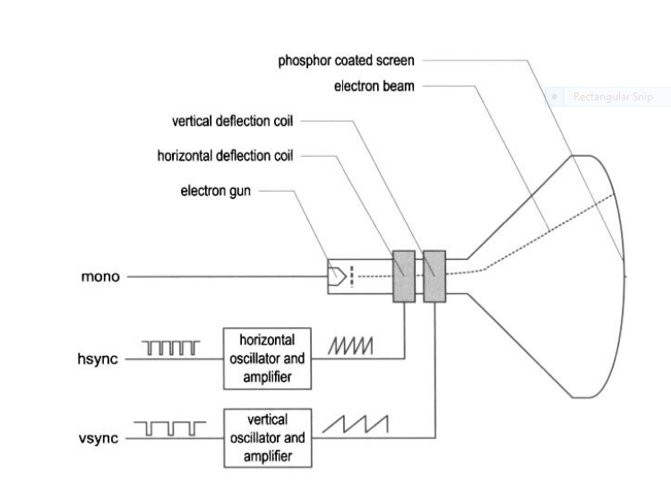

Conceptual Diagram

**Three-bit VGA color combinations**

|  |  |  |  |
| --- | --- | --- | --- |
| RED(R) | GREEN(G) | BLUE(B) | RESULTING COLOUR |
| 0 | 0 | 0 | BLACK |
| 0 | 0 | 1 | BLUE |
| 0 | 1 | 0 | GREEN |
| 0 | 1 | 1 | CYAN |
| 1 | 0 | 0 | RED |
| 1 | 0 | 1 | MAGENTA |
| 1 | 1 | 0 | YELLOW |
| 1 | 1 | 1 | WHITE |

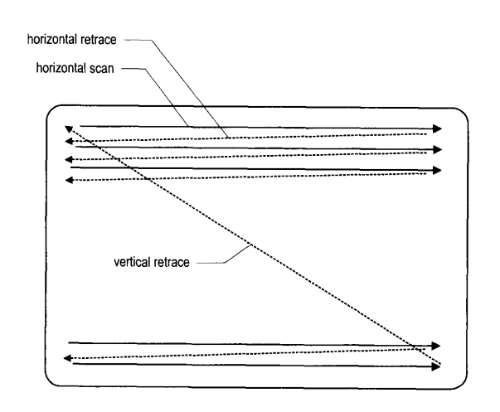

CRT scanning pattern.

The monitor's internal oscillators and amplifiers generate sawtooth waveforms to control the two deflection coils. For example, the electron beam moves from the left edge to the right edge as the voltage applied to the horizontal deflection coil gradually increases. After reaching the right edge, the beam returns rapidly to the left edge (i.e., retraces) when the voltage changes to 0. The relationship between the sawtooth waveform and the scan is shown in Figure 13.4.

Two external synchronization signals, hsync and vsync, control generation of the sawtooth waveforms. These signals are digital signals. The relationship between the hsync signal and the horizontal sawtooth is also shown in Figure.

Note that the " 1 " and "0" periods of the hsync signal correspond to the rising and falling ramps of the sawtooth waveform. The basic operation of a color CRT is similar except that it has three electron beams, which are projected to the red, green, and blue phosphor dots on the screen. The three dots are combined to form a pixel. We can adjust the voltage levels of the three video input signals to obtain the desired pixel color.

**3.3 Timing calculation of VGA synchronization signals**

As mentioned earlier, we assume that the pixel rate is 25 MHz. It is determined by three parameters:

* P : the number of pixels in a horizontal scan line. For 640-by-480 resolution, it is

P = 800 (pixels/line)

* L : the number of lines in a screen (i.e., a vertical scan). For 640-by-480 resolution, it

is

l = 525(lines/screens)

* S : the number of screens per second. For flickering-free operation, we can set it to

S = 60 (screens/second)

The s parameter specifies how fast the screen should be refreshed. For a human eye, the refresh rate must be at least 30 screens per second to make the motion appear to be continuous. To reduce flickering, the monitor usually has a much higher rate, such as the 60 screens per second specification above. The pixel rate can be calculated by the three parameters :

pixel rate = p * 1 * s = 25M (pixels/second)

The pixel rate for other resolutions and refresh rates can be calculated in a similar fashion. Clearly, the rate increases as the resolution and refresh rate grow.